ART | 1. What is it? | 2. How is it created? | 3. What does it mean?
List the details:  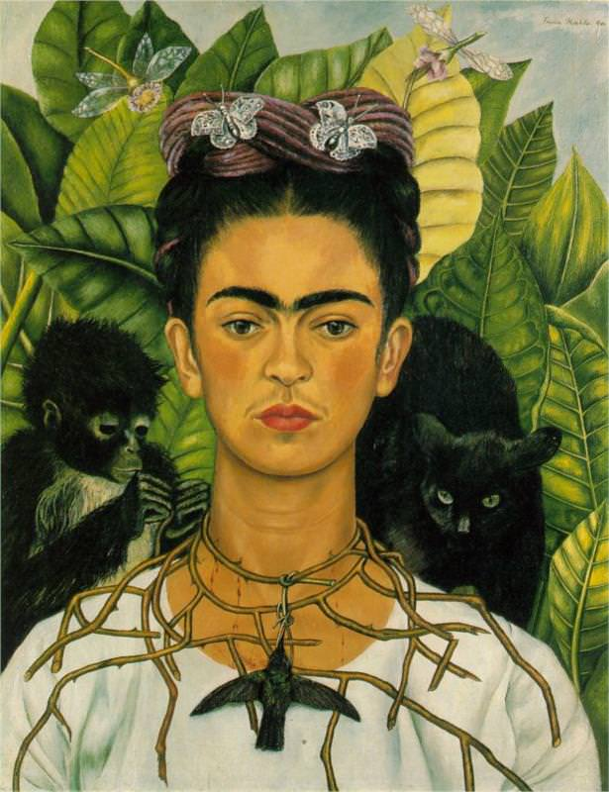  Self-Portrait with Thorn Necklace and Hummingbird  by Frida Kahlo | - Painting  - Depicting...  - Materials: What is it made of?  - Function: What does it do? | Technique: What is the artist doing with the materials?  Elements: How does the artist use line, color, form, shapes, figures, etc. to present their message?  Context: Who made it? When was it made? What is the history surrounding the artwork? PERSIA or GRAPES | When you put all the things together, that you’ve observed from the first two columns, what makes this painting important, or significant.  In other words, why is it meaningful?
Interpretations: | The art piece that I am looking at is a painting on canvas. It is a portrait surrounded by animals and plants. The figure, a woman, is wrapped in a thorn necklace.  I know /or/ I can infer about what the artwork is, because the materials are used to make a painting. It’s function is to communicate Kahlo’s ideas or message. | The artist used the paint colors black, white, yellow, green, and red to make a very bright painting.  The animals are all in dark colors. The thorns are piercing her neck and are arranged in a shape that looks like a net that has been cut. The woman is in the very center of the painting.  Frida Kahlo was a Mexican female artist who was famous for her depictions of her painful life, amid the symbols and colors of her Mexican culture. | The painting is a narrative of how Kahlo endured a lot of pain and suffering in her life. The animals in the painting surround her, and she is wrapped in a thorn necklace. She does not look happy and her neck is bleeding under the thorns.  This painting is meaningful in many ways. It is meaningful to the artist, because Kahlo used technique and elements to present her message about the pain in her life. The painting is significant today, because Kahlo’s painting is a combination of her life and her Mexican heritage.

ART | 1. What is it? | 2. How is it created? | 3. What does it mean?
List the details: | The artwork is...  The materials are...  The function, or what it does, is... | The technique(s) use/d are...  The elements included are...  The history or context of the artwork are... | This are work is meaningful to_______________, because...  This artwork is significant to________________, because...
Interpretations: | The artwork that I observe is... | The artist’s technique...  He/She uses the elements...  _______________ made this artwork, during __________________. | The ______________ is meaningful, because...  The ________________ is significant to ______________, because...

TEXT | 1. What does the text say? | 2. How does the text say it? | 3. What does the text mean?
List the details:  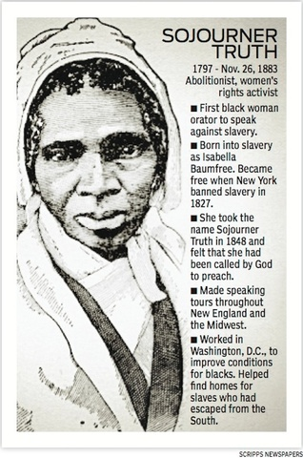  “Ain’t I a Woman?”  by Sojourner Truth | Sojourner Truth gave this speech about women’s rights during a women’s rights convention/meeting in 1851.  In the speech Truth says that women, especially African enslaved women, do the same things and are treated the same as men. Therefore, women deserved the same rights as men. | - Claim  - Evidence  - Reasoning /or/ Links  - Counterclaims  - Significance  Therefore, this speech is an argument.  - Truth’s claim is implied.  - Truth uses evidence from her own experience.  - Truth links her evidence to her claim by connecting her work to the fact that she is a woman.  - Truth uses other arguments to strengthen her argument. | Anti-feminist ideas were false. Women deserved to have the same rights as men.  Truth uses arguments against women’s rights to prove HOW and WHY anti-feminism is wrong.  - At the end of the speech, Truth listed her demands.
Interpretations:  How do I know what I know? | I know what the speech is saying, because Truth gave the speech at a Women’s Rights Convention in 1851 where women met to discuss getting rights. Also, in the introduction she stated why she was there, “I think that ‘twixt the negroes of the South and the women at the North, all talking about rights, the white men will be in a fix pretty soon. But what’s all this here talking about?” | I know that Truth’s speech is an argument, because...  Claim: Women deserve the same rights as men, because many women already did and were treated like men.  Evidence:”That man over there says that women need to be helped into carriages, and lifted over ditches, and to have the best place everywhere. Nobody ever helps me into carriages, or over mud-puddles, or gives me any best place!  Reasoning: “And ain’t I a woman?”  Counterclaim:”Then that little man in black there, he says women can’t have as much rights as men, ’cause Christ wasn’t a woman!” | Significance:”...the men better let them.”  Throughout the speech, Truth consistently presents her claim against the counterclaims of men who were against giving rights to women. This leads me to believe that the importance of her speech was to disprove the anti-feminist arguments.

TEXT | 1. What does the text say? | 2. How does the text say it? | 3. What does the text mean?
List the details:  Title of the text and Author’s name. | This text is a... (speech, article, book, web page, etc.)  The main idea /or/ claim is...  The author or source of this text is...  Write the main idea in your own words. | List the details...  Name the text structure: (explanatory, narrative, argument, compare and/or contrast, sequence of events, chronological, etc.)  Describe, without using evidence from the text, how the author structures the text. | The purpose of this text is...  Point out the general location or time in the text (beginning, middle, or end) where or when the meaning is revealed.
Interpretations:  How do I know what I know? | I know what the text is saying, because...  For example... | I know how the text is structured, because...  For example... | I know what the text means, or its purpose, because...  For example...

